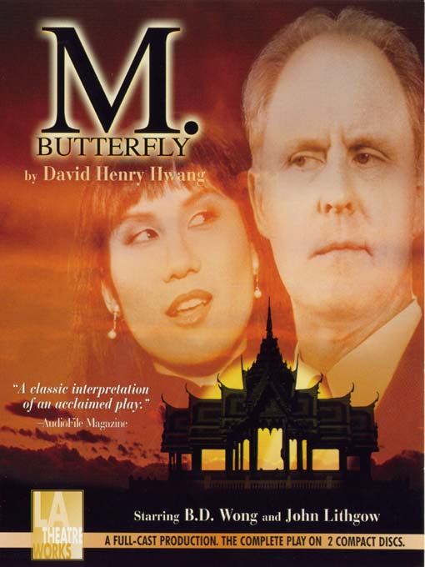

Don Henke & Kelly Young
David Henry Hwang
David Henry Hwang is a world-renowned playwright and arguably the greatest Asian American dramatist. Hwang was born in Los Angeles, California on August 11 1957. Hwang was the product of two extremely successful parents as his father was a successful businessman and the founder and owner of a bank while his mother was a professional pianist (Kim, 126). His mother’s musical talents clearly made a strong impact on Hwang as he took up the violin at the young age of seven, which is around the same age where he was introduced to the theater. Not one to desire the spotlight, Hwang never participated as an actor in any of his high school’s productions but rather enjoyed staying after the productions to listen to the director give notes (Kim 126).
Hwang went to Stanford University where he majored in English. It was during his years as an undergraduate student at Stanford that Hwang started to write plays without any formal training in playwriting (Kim 127). Realizing that he needed some professional assistance if he was going to be a successful playwright, Hwang reached out to Sam Shepard and Maria Irene Fornes for some guidance and mentorship. Hwang eventually garnered a following and earned himself a good deal of success. With this success come other responsibilities that Hwang was not ready for, one of which was the fact that he was made an unofficial spokesman for Asian Americans. Hwang did not embrace this label however and felt that too much emphasis was put on his heritage. This led to a two year absence from writing only to come back with Rich Relations, arguably the biggest flop of Hwang’s career. This was Hwang’s first play not dealing with ethical issues and was more of an autobiography. Ironically enough, it was not until after Rich Relations that Hwang knew he wanted to be a playwright for the rest of his life, saying that the flop was “liberating” (Kim 131).
M. Butterfly opened in Broadway in 1988 to mixed reviews, mostly negative though. Even with such negative reviews, M. Butterfly went on to be extremely successful, grossing over $35million in the box office in the United States alone. Due to the extreme success of the play Hwang was once again forced to be a spokesman for Asian Americans, a role he was more comfortable with this time around (Kim 128). Hwang currently resides in New York City with his wife and son and is writing a good deal of librettos seemingly not focusing on race as heavily.

Work Cited
Kim, Esther S. Miles Xian Liu. Asian American Playwrights: A Bibliographical Critical Sourcebook. Greenwood. 30 March 2002.
Other Stage Works
As the Crow Flies (1986)
Bang Kok (1996)
Bondage (1992)
Face Value (1993)
Family Devotions (1981)
FOB (1980) First Play, written while in Stanford
Golden Child (1998)
The Great Helmsman (2007)
Jade Flowerpots and Bound Feet (2001)
M. Butterfly (1988)
Merchandising (1999)
Peer Gynt (1998) Adaptation of Henrik Ibsen’s play of the same name
Rich Relations (1986) First play with Non-Asian Characters
Sound and Beauty
The Dance and the Railroad (1981)
The House of Sleeping Beauties (1983) Adaptation of Yasunari Kawabata’s play of the same name
The Sound of a Voice (1983)
Tibet Through the Red Box (2004)
Trying to Find Chinatown (1993)
Yellow Face (2007) Obie-Award Winning Play. Hwang is the protagonist
Core Texts
Davis, Rocio G. “Just a Man: Subverting Stereotypes in David Henry Hwang’s M. Butterfly.” Hitting Critical Mass: A Journal of Asian American Cultural Criticism 6.2 (2000): 59-74. MLA International Bibliography. EBSCO. Web. 27 Nov, 2010
DiGaetani, John Louis. “M. Butterfly: An Interview with David Henry Hwang.” TDR: The Drama Review: A Journal of Performance Studies 33.3 [T123] (1989): 141-153. MLA International Bibliography. EBSCO. Web. 28 Nov. 2010.
Kang, Hyeong-min. “Unmasking the Colonial Politics of Violence: David Henry Hwang’s M. Butterfly.” Journal of Modern British and American Drama 18.1 (2005): 23-46. MLA International Bibliography. EBSCO. Web. 27 Nov. 2010.
Kondo, Dorinne K. “M. Butterfly: Orientalism, Gender, and a Critique of Essentialist Identity.” Cultural Critique 16.0 (1990): 5-29. MLA International Bibliography. EBSCO. Web. 28 Nov. 2010
Ross, Deborah L. “On the Trail of the Butterfly: D.H. Hwang and Transformation.” Beyond Adaptation: Essays on Radical Transformation of Original Works. 111-122. MLA International Bibliography. EBSCO. Web. 28 Nov. 2010
Rossini, Jon D. “From M. Butterfly to Bondage: David Henry Hwang’s Fantasies of Sexuality, Ethnicity and Gender.” Journal of American Drama and Theatre 18.3 (2006): 54-76. MLA International Bibliography. EBSCO. Web. 28 Nov. 2010
Saal, Ilka. “Performance and perception: Gender, Sexuality, and Culture in David Henry Hwang’s M. Butterfly.” Amerikastudient/American Studies 43.4 (1998): 629-644. MLA International Bibliography. EBSO. Web. 27 Nov. 2010
Skloot, Robert. “Breaking the Butterfly: The Politics of David Henry Hwang.” Modern Drama 33.1 (1990): 59-66. MLA International Bibliography. EBSCO. Web. 28 Nov. 2010

M. Butterfly Summary
The play begins in Gallimard’s prison cell in Paris; the action regularly shifts between this and Beijing, as he tells his story of working in China for the French Embassy. Regularly throughout the play, Gallimard makes references to or explains how his own life correlates to the plot of Puccini’s opera, Madame Butterfly, which tells of an Asian woman, the ideal of a female, who fell in love with a white man, bore his child, and then killed herself after meeting his wife; from the very opening scene, the music is played in correspondence to Gallimard’s story.
From the beginning, we are told that Gallimard is a subject of mockery and laughter in regular conversation; we are shown an upper class conversation that hints at what has caused Gallimard’s fame. Gallimard takes the third scene to tell the audience the myth of the “perfect woman”; he also uses the two characters of Pinkerton and Sharpless from the original opera to describe himself and Marc: Gallimard, the timid and ungallant American, Marc as the seizing womanizer.
Gallimard is clearly uncomfortable with, if not embarrassed by, a woman’s own pride in her sexuality in the next scene, when he talks to Marc about the pool party and also encounters the pin up girl; this gives us a better idea of Gallimard and his “perfect woman” ideal and a better understanding of why he fell in love with Song, his own Butterfly: when he sees her performing the original opera, he is mesmerized by her “delicacy” and suffering. Later, he becomes attracted to her understanding of male and female roles in the Eastern and Western world.
As the relationship with Song progresses through mind games, we are introduced to the character of Chin, who reveals the true nature of Song’s character: “She” is in fact a “he,” sacrificing his dignity for his country. Her eventual “submission” to Gallimard is merely an act to cause him to fall in love with the image of Butterfly; Song goes to such lengths as to claim shame, shyness and modesty when asked to perform sexual acts; Gallimard, in his blind enjoyment of dominance over her, agrees to whatever she proposes. Later, Song even expresses interest in finding a child. It is unknown if this is for more spying purposes or Song’s on enjoyment as acting as Butterfly.
The demise of Gallimard unfurls with his confession to Marc, his wife Helga, his employer Toulon, and before a French court. Even after acknowledging that Song is a man, Gallimard refuses to admit it to the public. Finally, a confrontation with Song and Gallimard’s suicide leaves many questions: Who or what did he really fall in love with? Is it really a man that makes the ideal woman? Could a real woman have achieved what Song had by acting? Did Song enjoy his time spent as Butterfly or was it purely for political reasons? Why does the play end on Song and not Gallimard’s death?

Current State of Scholarship
Many things written on M. Butterfly gloss over the fact that this was a play based on true events; the most we get is the typical mention “based on actual events” and briefly in the Digaetini interview, Hwang stating that Bouriscot should get some sort of royalty for his actions. More articles seem to be interested in Hwang’s presented ideas and views of colonialism, women, and sex, as well as the overwhelming presence of dominance that takes place in the play concerning genders and races.
In Hwang’s own mind, M. Butterfly is a commentary and display of specifically the upper class white man’s view of those struggles. Song gives this to us in two instances. The first is when he states it took a man to give the idea of the perfect woman; the other is when he states, “… being an Oriental, I could never completely be a man.”
M. Butterfly, with all its controversies, opened on Broadway to a highly successful run, which lasted nearly two years; in London, it broke many of the box office records. Aside from being nominated for a Pulitzer Prize, it won multiple Drama Desk and Tony Awards and was adapted into a less successful film. (Coincidentally one year after it closed, Boubil and Schoenberg opened their own musical version of Madame Butterfly in the form of Miss Saigon.) There are currently no plans to bring M. Butterfly back to Broadway, although independent theater companies perform it around the country sporadically.

