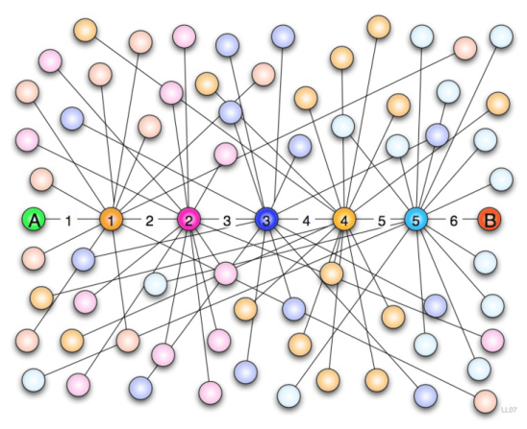
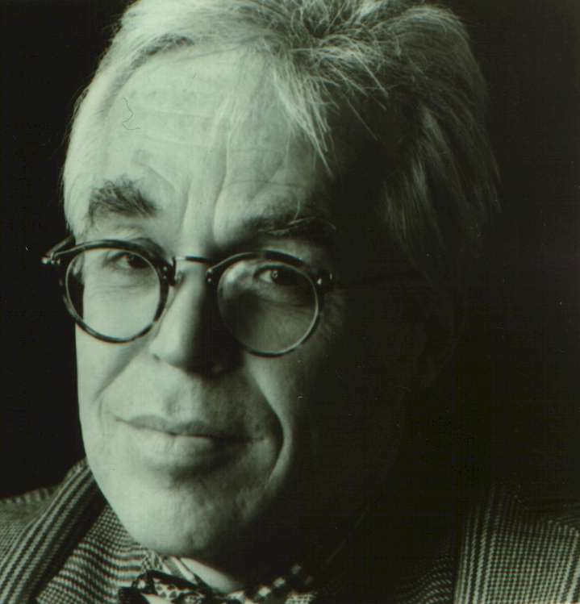
John Guare’s Six Degrees of Separation:
A Literary Resource Guide

By

Adam Ludwig and Scott Schneider

About the Author

John Guare was born in 1938 and grew up in Queens, NY. He was educated in Catholic schools and attended daily mass with his mother. At age 11, Guare wrote his first play which garnered attention from the Long Island newspaper, Newsday. He attended plays each week throughout his teen years, especially admiring musicals and Anton Chekhov’s works. As an undergraduate student at Georgetown, he wrote new plays each year and was involved with the local theatre scene. He graduated from Georgetown University in 1960 with a B.A. in English. Guare then attended graduate school at Yale University and earned his M.F.A. in playwriting in 1963. After graduating from Yale, Guare spent six months in the U.S. Air Force Reserves and then hitchhiked through Europe in 1965, which partly inspired one of his most popular plays, The House of Blue Leaves.

Guare was devastated by his father’s death in 1966 and wrote several one-act plays, partly due to his inability to focus on full-length works. This practice of writing uninterrupted, short works developed into his stylized hallmark. He won an Obie for his one-act play Muzeeka, which had its New York debut at the Provincetown Playhouse and ran for sixty-five performances. In the late 1960’s Guare participated in anti-war protests and this subject infiltrated his work during the time period including his plays, Cop-Out and Home Fires. In 1971, he won critical acclaim for The House of Blue Leaves, which is a farce about a zookeeper who murders his insane wife after he fails in his attempt as a songwriter. During this time period, he also won a Tony and the New York Drama Critics Circle award for his musical staging of Shakespeare’s Two Gentlemen of Verona. Other seminal texts of Guare include Six Degrees of Separation, Lydie Breeze, Gardenia, and Women and Water.

Guare has been called "the great romantic poet of contemporary American theatre" by Richard Christiansen. Biographer Suzanne Deickman asserts that, “Loneliness, alienation, and a bitter resentment of the way in which people substitute fantasies inspired by religion, the media, or literature for real living inform Guare's writings.” Gene Plunka offers the following incisive statement about his body of work: “Guare is motivated by scorn for the fraudulence of American life. His protagonists fail to ‘connect’ with others and with their own unique sense of individuality. Instead, they are lured by the glitz and glamour of the promised American Dream.”

Works Cited:

Dieckman, Suzanne. "John Guare." Twentieth-Century American Dramatists. Ed. John MacNicholas. Detroit: Gale Research, 1981. Dictionary of Literary Biography Vol. 7. Literature Resource Center. Web. 11 Nov. 2010.

Plunka, Gene A. "John Guare." Twentieth-Century American Dramatists: Third Series. Ed. Christopher J. Wheatley. Detroit: Gale Group, 2002. Dictionary of Literary Biography Vol. 249.Literature Resource Center. Web. 11 Nov. 2010.

Plot Summary

The play, set in Louisa (Ouisa) and Flan (Flanders) Kittredge’s apartment, above which spins a two-faced Kandinsky masterpiece. The painting, then, introduces the motif of reality and appearance, which presages Paul’s entrance. The two, a pair of art dealers, begin the dialogue on the day/evening after the play’s central action occurs, thus creating a flashback. They tell us they were having a great evening the night before as they entertained their “King Midas rich” South African friend, Geoffrey, from whom they wished to procure two million dollars in order to purchase a painting by Cezanne that they can then turn around and sell to Japanese collectors for ten million.
Paul, bloody and beaten, enters in the midst of their conversation about the painting and claims to be a friend to their children. He claims that he has been mugged in Central Park and that the muggers have taken his money and his briefcase containing his thesis. After the initial confusion subsides and Geoffrey, who has grown uncomfortable, is appeased with a book on Cezanne, the three settle in to hear Paul speak of Harvard, the Kittredge’s children and…Paul’s (claimed) father, Sidney Poitier, who is currently making a movie version of the Broadway musical Cats. They are star-struck. Paul cooks dinner for the three, and the Kittredges, afterward, offer him the opportunity to stay there for the evening instead of sending him off to a hotel. After dinner, Geoffrey leaves; Flan, concerned about the unfinished business deal, follows him into the hall. He returns triumphantly, saying that Geoffrey is “in” for the two million. That evening, Ouisa inadvertently stumbles into Paul’s room, wherein Paul and a male Hustler are engaged in sexual intercourse. After expelling him, they have dinner a night later with their friends, Kitty and Larkin, who tell a story that mirrors their own experience with Paul.
The two couples decide to involve the police who dismiss them, and, finally, bring their kids in on the story. The dismissive Detective later calls to tell them of Dr. Fine, another victim of Paul’s masquerade, who, like the Kittredges and their friends, was fooled by Paul but lost no valuables. They’ve had enough; they attempt to put their kids on the case, assuming they might all know him as a classmate from their common boarding schools. This backfires, and the parents leave in humiliation. The four kids begin flipping through their yearbook and find Trent Conway, who, after being asked, confesses to a three-month relationship wherein he gave Paul constant access to his address book and vital information about the names registered within. This turn of events, now, gives rise to the play’s title; the “victims” Paul has met are separated by degrees, but linked to a common person somehow. In this case, Paul has made himself that common link by forcing himself into their lives and social circles.
At this point, we are introduced to Elizabeth and Rick, two young people from Utah who meet Paul in Central Park as he begins to pass himself off as the bastard, ignored son of Flan Ouisa. His tale enmeshes them, and they empty their bank accounts to help him. Rick, after a night with Paul, gives in to sex with Paul, who then vanishes, leaving Rick broke and ruined. Rick kills himself, and Elizabeth wants charges pressed against Paul.
The last section of the play ends with a phone call, as Paul, who interrupts a call between Ouisa and her daughter, attempts to crawl back into their lives. He is rebuffed; he is turned into the police after revealing his location; he (implicitly) commits suicide in Rikers. They leave…to go to another auction.
Author’s Noted Works
(not including anthologized works)

- The House of Blue Leaves (1971)
- Two Gentlemen of Verona (adaptation – 1971)
- Marco Polo Sings a Solo (1973)
- Optimism, or The Adventures of Candide (adaptation – 1973)
- Landscape of the Body (1977)
- Lydie Breeze (1982)
- Moon Over Miami (1987)
- Six Degrees of Separation (1990)
- Four Baboons Adoring the Sun (1992)
- Sweet Smell of Success (2001)
- A Few Stout Individuals (2002)
- A Free Man of Color (2010)

Core Texts

Gillan, Jennifer. "Staging a Staged Crisis in Masculinity: Race and Masculinity in Six
Degrees of Separation." American Drama 9.2 (Spring 2000): 50-73. Rpt. in Drama Criticism. Ed. Janet Witalec. Vol. 20. Detroit: Gale, 2003. Literature Resource Center. Web. 8 Nov. 2010.

Kolin, Philip C., ed. American Playwrights Since 1945 : a Guide to Scholarship, Criticism, and
Performance. New York : Greenwood Press, 1989. Print.

Krasner, David, ed. A Companion to Twentieth-Century American Drama. Malden, MA :
Blackwell, c2005. Print.

Plunka, Gene A. "The Black Comedy of John Guare: Six Degrees of Separation." Essays in
Theatre/Etudes Théâtrales 17.2 (1999): 165-176. MLA International Bibliography. EBSCO. Web. 8 Nov. 2010.

Plunka, Gene A. "Six Degrees of Separation." The Black Comedy of John Guare.
Newark, Del: University of Delaware Press, 2002. 186-202. Rpt. in Contemporary Literary Criticism. Ed. Jeffrey W. Hunter. Vol. 196. Detroit: Gale, 2005. Literature Resource Center. Web. 11 Nov. 2010.

Slethaug, Gordon E. "Chaotics and Many Degrees of Freedom in John Guare's Six Degrees of
Separation." American Drama 11.1 (2002): 73-93. MLA International Bibliography. EBSCO. Web. 8 Nov. 2010.
Current State of Scholarship on
John Guare’s
Six Degree of Separation

Much of the current state of scholarship revolving around Guare’s work seems to be driven by theatre reviews, which place the dialogue at a superficial level. Critics, it seems, have only begun to delve into the deeper levels of the socio-cultural implications of some his more recognized works such as The House of Blue Leaves or Six Degrees of Separation.
Having noted this, however, it is obvious that Six Degrees is considered, by most of Guare’s critics, to be his masterpiece. Scholars focus on how the play relies on “metatheatrical techniques that assist the actors in addressing the audience” as ways to understand the play’s confrontation of issues about race, class, and dignity (Six Degrees). According to Gene Plunka, “the effect of having the actors sit closely to the stage to appear and vanish at will, reinforc(es) the notion that the tale is being narrated as performance art” (Six Degrees). The play breaks fourth-wall conventions, thereby allowing the audience to become part of the spoof on the sort of soap-opera-like plot while simultaneously remaining at a critical distance from its action.
Plunka maintains that the play is a lens through which we might take a critical stance toward the concept of Radical Chic, a social phenomenon wherein members of the upper class gain access and pander to other groups they perceive as oppressed. Each of the “victims” in the play sees Paul as downtrodden; first, through his falsified mugging, but then through a twisted sort of sympathy for his need to join their ranks. According to Plunka, “the leitmotif of the play involves the fragmentation of the psyche and our efforts to connect with self and others in a society where we are constantly alienated” (Six Degrees). Ouisa and Flan, too, are empty and come to rely on duplicity in order to fill their lives with some sort of identity.
Other critics, such as Jennifer Gillan, take a more socio-cultural approach, placing the play in the context of its historical time period. As a post-Vietnam, post-Reagan era play, the text, according to Gillan, “dramatizes the shifting of blame for social and economic exploitation and general societal decay onto a ‘deviant’ individual” (Gillan). According to critics like Gillan and other cultural theorists she mentions such as Susan Jeffords, Michael Rogin and Laurel Berlant, the Reagan era attempted, in cultural and social circles, to re-instate a sense of masculinity many perceived as lacking during the disco and Carter eras. The play, then, is “able to ‘mirror and amplify…’ the hypocrisy of the imagined national community that faults citizens for their failure to realize a promise from which they are already excluded” (Gillan).
In spite of the apparent relatively scant and fractured nature of the scholarship regarding Guare’s work, the consensus among critics seems to place this play at the head of his body of work. The play’s examination of American class structure, post-modern alienation, and splintered socio-cultural consciousness makes it stand out among masterpieces of post-modern, post-WW II American drama.

